**DATA COMMUNICATION**

**LAB 7: INTERFACE I2C LCD**

# Introduction

In this manual we will learn how to interface an LCD (Liquid Crystal Display) to the NodeMCU board. These 16x2 LCDs are very popular and broadly used in electronics projects as they are good for displaying information like sensor data from your project, and also they are very cheap.

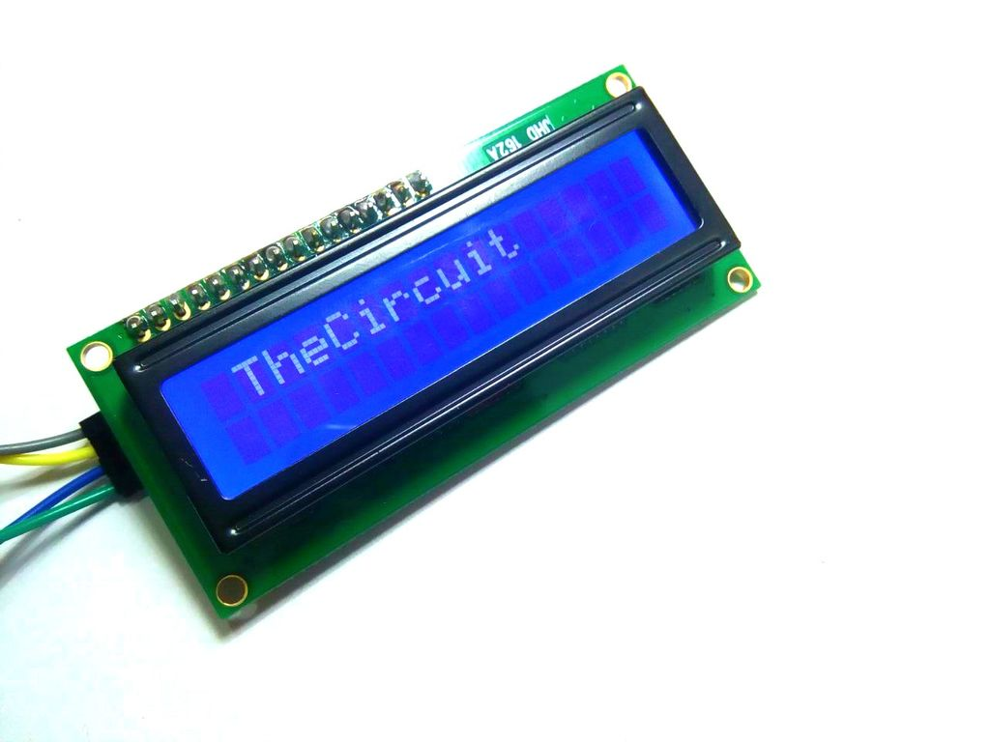

Figure 1: 16x2 LCD

Connecting LCD to I2C and then interfacing it to NodeMCU is very simple (see Figure 2):

1. GND pin of I2C is connected Ground pin (GND) of the NodeMCU.
2. VCC pin of I2C is connected 3.3V pin (or Vin) of the NodeMCU
3. SDA pin of I2C is connected D4 of the NodeMCU.
4. SCL pin of I2C is connected D3 pin of the NodeMCU.

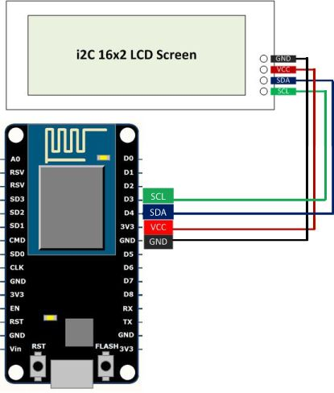

Figure 2: Wire connection for I2C interface

# Getting Started

First thing we need to do is to insert the Liquid Crystal Library. We can do that like this: **Sketch > Include Library > Manage Libraries >** **LiquidCrystal_I2C LCD**

Snip code to display on this LCD can be found bellow:

#include <Wire.h>

#include <LiquidCrystal_I2C.h>

LiquidCrystal_I2C lcd(0x3F, 16, 2);

void setup()

{

Wire.begin(2,0);

lcd.init(); // initializing the LCD

lcd.backlight(); // Enable or Turn On the backlight

lcd.print(" Hello World "); // Start Printing

}

# Exercise

1. Figure out library for this I2C LCD and explain the value 0x3F used in the source

LiquidCrystal_I2C lcd(0x3F, 16, 2);

0x3F: I2C slave address of the LCD display

1. Implement the shift-left animation for the string Hello World.

void loop(){

timeCurrent = millis();

if (timeCurrent - timePrev >= 500){

timePrev = timeCurrent;

if (i > 15){

i = 0;

}

else {

tmp = s.substring(i);

for (short j = 0; j < i; j++)

tmp += s.charAt(j);

lcd.setCursor(0, 0);

lcd.print(tmp);

i++;

}

}

}

# Extra Exercise

Connect 2 LCDs and consider them as one bigger screen. Implement a shift-left animation of a string in this bigger screen.